



eIdeas

**User Guide to:**

**Ideas**

**Created by !cool**

**Table of Contents**

**1. Creating an Idea……………….……………………………………………………………......1**

**2. Deleting an Idea…………….…………………....................................……………………………………3**

**3. Searching for Ideas.......……………….....……………………………………………………………......4**

**4. Editing……….…………….........................................................................………………………6**

**5. Commenting……….…………….........................................................................………………………6**

**6. View Idea……….…………….........................................................................………………………6**

**List of Figures**

Figure 1-1. Login Page: Register...…………………………..………………………………………………......1

Figure 1-2. Filled Register Page.…………………….................................……………………………………2

Figure 1-3. Errors on Registration Page..................................................................………………………2

Figure 2-1. Login Page……….…………..........................................................................………………………2

Figure 3-2. Login Page: Forgot Password.………...…............................................………………………4

Figure 3-2. Forgot Password Page.………...……......................................................………………………5

Figure 3-3. Forgot Password Page: Email Sent…..……………............................………………………5

Figure 4-1. Logging Out..............................................…..……………............................………………………6

**1. Creating an Idea**

1. If you do not have an account, go to the Register page by clicking on “Register” in the top right of the screen OR by clicking “Register as a new user” near the bottom of the log in page. The login page and where to click are shown below.

***Figure 1-1. Login Page: Register***

1. Once you are at the Register page, shown in Figure 1-2, fill in your information. You will need to choose a password that is at least 6 characters long, has at least 1 of the following: a number, a symbol, an uppercase letter, and a capitalized letter. You will also need to retype your password a second time. This ensures your password is correctly typed.
2. To upload an image, click the “Choose File” button and select an image from your computer. A red box in Figure 1-2 below shows this button.
3. When all fields are filled out, press the “Register” button at the bottom of the page; a red box in Figure 1-2 below shows this button.
4. If there are any problems, your account will not be registered and an error will show in red detailing the problem. You will need to fix all errors and follow all guides to properly register. An example of this error is shown in Figure 1-3.
5. If there are no problems, your account will be created and you will be able to use the site properly.

***Figure 1-2. Filled Register Page***

***Figure 1-3. Errors on Registration Page***

**2. Deleting an Idea**

1. If you have an account and would like to login, go to the Login page by selecting “Login” from the top right corner and fill in your information. You will need your email and password before pressing “Log In”. The “Login” buttons are shown in Figure 2-1.
2. Selecting “Remember me?” will allow for quicker access to login, however it may make it easier for other people to get onto your account if your computer is shared with other people.
3. Once logged in, you can access eIdeas normally.
4. If you do not see the “Login” button, but instead see a “Logout” button then you or another person is already logged in.

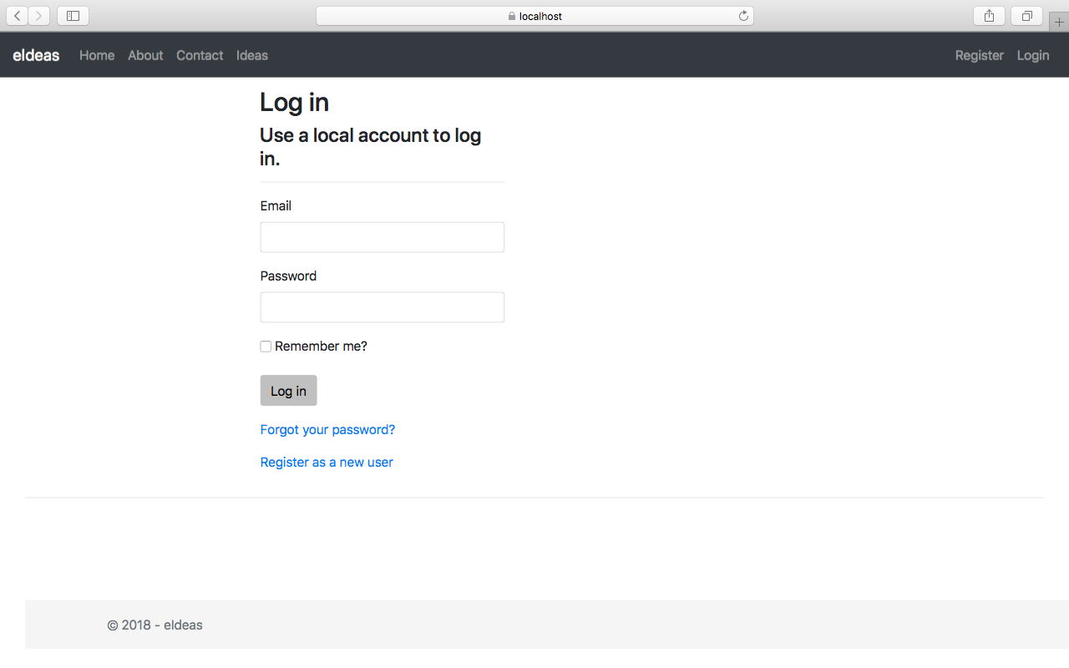

***Figure 2-1. Login Page***

**3. Editing an Idea**

1. If you have forgotten your password and cannot login, go to the Login page by clicking “Login” at the top right of the page.
2. Next, click on “Forgot your password?” shown below in Figure 3-1.
3. This will bring you to a page prompting for your email. Enter your email and press the submit button. This is shown in Figure 3-2. An email with instructions on how to reset your password will be sent to your email, so ensure you have access to it. Sending the email will NOT reset your password.
4. Once your password is changed, you should be able to login with the new password. If you still cannot login, repeat steps 1-3.



***Figure 3-1. Login Page: Forgot Password***

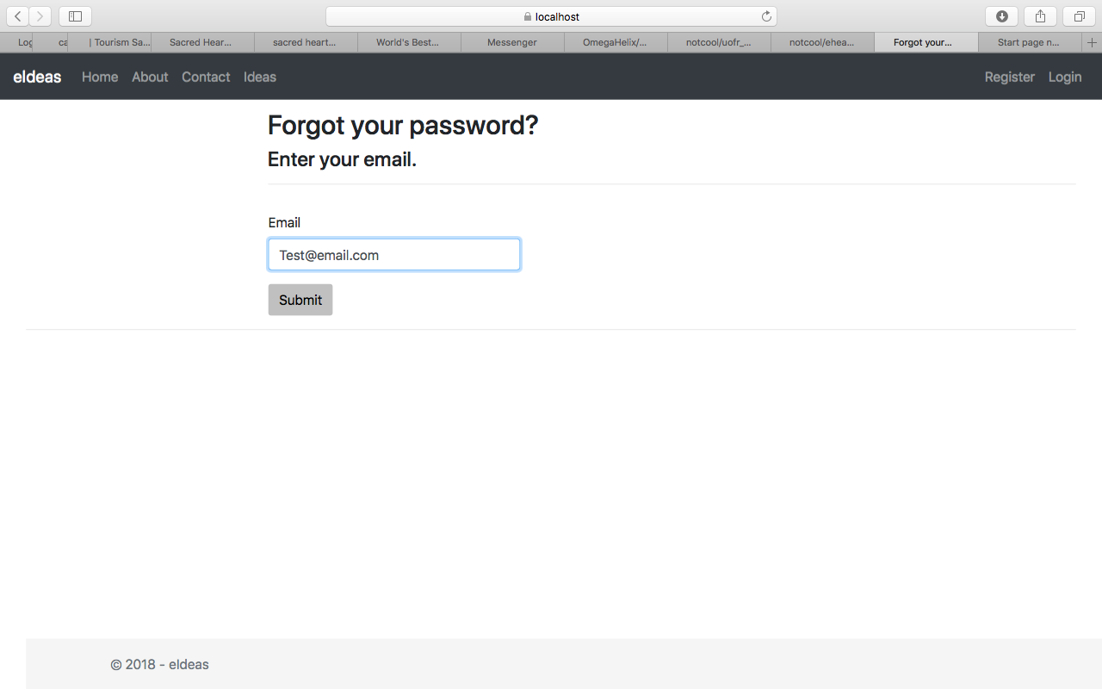

***Figure 3-2. Forgot Password Page***

***Figure 3-3. Forgot Password Page: Email Sent***

**4. Logging Out**

1. When you are ready to log out, press the “Logout” button in the top right hand corner shown in Figure 4-1. Pressing this will log you out and bring you to the login page.
2. If there is no “Logout” button, but there is a “Login” button then you are logged out.

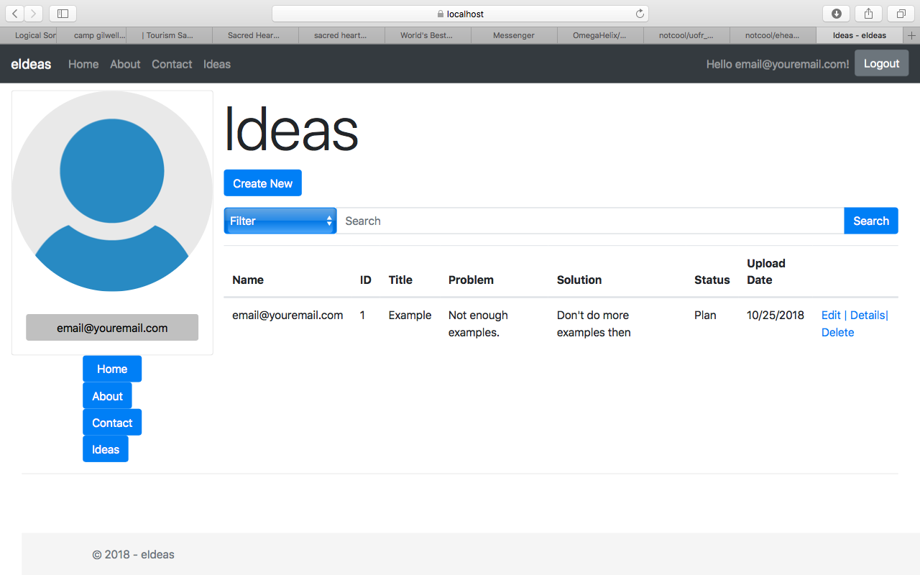

***Figure 4-1. Logging Out***